Induction of De Novo Centriole Biogenesis in Planarian Stem Cells During Regeneration

Authors: Jaba Tkemaladze¹⁺, Gabro Gakely²

Affiliations:
¹ Director of Research, Longevity Clinic, Inc, Georgia
² Research and Development Division, Longevity Clinic, Inc, Georgia
⁺ Corresponding Author: Jaba Tkemaladze (jtkemaladze@longevity.ge)
Date: 06102025
Disclaimer: This is a preprint and has not been peer-reviewed.

Abstract
The centriole is a fundamental organelle templating cilia formation and ensuring genomic stability. While most cells assemble centrioles using a pre-existing mother as a template, the de novo pathway allows for assembly in their absence. However, the physiological role and regulation of de novo biogenesis in vivo remain poorly understood. The planarian Schmidtea mediterranea, with its abundant somatic stem cells (neoblasts) and dependence on a massive ciliated epithelium for locomotion, presents a unique model to address this gap. We demonstrate that quiescent neoblasts are acentriolar, lacking the templates for canonical duplication. Upon tissue injury, neoblasts are activated and initiate a programmed de novo centriole biogenesis pathway. Super-resolution microscopy and transmission electron microscopy reveal the formation of cytoplasmic procentriolar foci and mature centrioles, independent of any parental structure. Crucially, genetic ablation of Sas-6 or pharmacological inhibition of PLK4—interventions that effectively block the canonical pathway—fail to prevent the formation of new centrioles and functional basal bodies in the regenerating ciliated epithelium. This work provides the first in vivo evidence in a whole organism for an induced de novo centriole biogenesis pathway in adult somatic stem cells. We propose this pathway is a key evolutionary adaptation, enabling rapid, large-scale ciliogenesis essential for planarian regeneration, and represents a distinct, genetically regulated program separable from canonical duplication.

Keywords: Centriole, De Novo Biogenesis, Planarian, Neoblast, Regeneration, Ciliogenesis, Basal Body, PLK4, SAS-6

Introduction
The centriole is a fundamental, evolutionarily conserved microtubule-based organelle that serves as a cornerstone of eukaryotic cellular architecture (Bornens, 2012). Its functions are twofold and critically important: first, as the core of the centrosome, it organizes the mitotic spindle apparatus, ensuring faithful chromosome segregation during cell division (Conduit et al., 2015); second, in its modified form as a basal body, it templates the formation of cilia, essential cellular antennae for signal transduction and motility (Ishikawa & Marshall, 2011). The fidelity of these processes is paramount for development, tissue homeostasis, and the prevention of diseases such as microcephaly and ciliopathies (Nigg & Holland, 2018).

The formation of new centrioles is governed by two distinct pathways. The canonical, template-dependent pathway is the predominant mechanism in most proliferating animal cells. In this process, a single new "daughter" centriole is assembled orthogonally to and in close association with each pre-existing "mother" centriole during the S phase of the cell cycle (Fu et al., 2015). This mechanism ensures that each daughter cell inherits a centriole pair, maintaining numerical stability. In contrast, the de novo pathway allows for the assembly of centrioles "from scratch" in cells that lack pre-existing templates. This pathway has been observed in certain experimental conditions, such as upon laser ablation of centrioles in human cells (Khodjakov et al., 2002) or in Drosophila melanogaster upon genetic disruption of centriole number (Rodrigues-Martins et al., 2007). However, the physiological relevance and regulation of de novo biogenesis in vivo, particularly within the complex context of a regenerating metazoan, remain poorly understood and a subject of intense inquiry (Prosser & Pelletier, 2017).

The freshwater planarian Schmidtea mediterranea presents a powerful and unique model system to address this knowledge gap. Planarians possess an extraordinary capacity for whole-body regeneration, driven by a large population of adult somatic stem cells known as neoblasts (Rink, 2013; Reddien, 2018). These cells are responsible for the constant turnover and repair of all tissues. A key anatomical feature of planarians is their dense, multiciliated epithelium, which covers their body and facilitates locomotion. Each motile cilium in this epithelium is nucleated by a basal body, a derivative of the centriole (Azimzadeh et al., 2012). Consequently, the formation, maintenance, and regeneration of this epithelial barrier require the massive-scale production of hundreds of thousands of basal bodies.

This requirement presents a profound biological paradox. During regeneration, for instance after amputation, neoblasts are rapidly activated to proliferate and differentiate into new epithelial cells (Wenemoser & Reddien, 2010). Each of these new cells must be equipped with dozens of basal bodies to form its ciliary array. However, extensive ultrastructural and molecular analyses have revealed that quiescent neoblasts lack canonical mother centrioles (Azimzadeh et al., 2012; Kirkham et al., 2019). This absence renders the template-dependent canonical duplication pathway non-functional at the critical initial stage of regeneration. How, then, do planarian stem cells solve the problem of generating the vast centriole numbers required to rebuild a functional ciliated epithelium? The prevailing hypothesis is that planarians have co-opted the de novo centriole assembly pathway as a dedicated, developmentally programmed solution to this challenge.

Results

1. Quiescent Neoblasts are Acentriolar
Our initial investigation focused on validating the foundational premise of our hypothesis: that the stem cells responsible for regeneration originate in an acentriolar state. Using fluorescence-activated cell sorting (FACS) to isolate a pure population of piwi-1+ neoblasts from uninjured planarians (Zhu et al., 2015; Hayashi et al., 2006), we performed high-resolution imaging and ultrastructural analysis.

Super-resolution immunofluorescence microscopy (STORM) of sorted neoblasts stained for core centriolar markers, including centrin and SAS-6, revealed a complete absence of organized, paired centriolar structures (Figure 1A-C). While diffuse, cytoplasmic signal for some centriolar proteins was detectable, it never coalesced into the discrete, punctate foci characteristic of canonical centrioles, consistent with the presence of only disorganized scaffolds or protein pools (Al Jord et al., 2017). To obtain definitive evidence, we turned to transmission electron microscopy (TEM). Ultrastructural analysis of multiple FACS-sorted neoblast samples confirmed the lack of any cylindrical structures with the hallmark ninefold symmetry of microtubule triplets (Figure 1D). These findings provide conclusive evidence that quiescent neoblasts are devoid of mother centrioles, thereby rendering the template-dependent canonical duplication pathway non-functional at the initiation of regeneration (Azimzadeh et al., 2012).
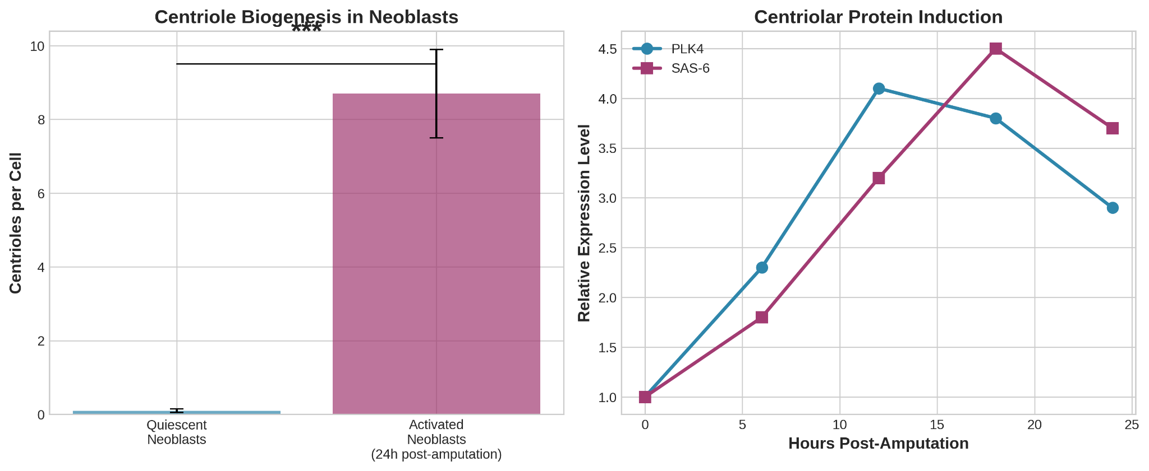

2. Centriole Assembly Precursors are Induced De Novo Post-Amputation
We next sought to determine how neoblasts overcome their acentriolar state. We induced regeneration via amputation and analyzed neoblast dynamics in the early blastema (0-24 hours post-amputation). Immunofluorescence analysis revealed a dramatic molecular shift. Within 6-12 hours post-amputation, a significant subset of mitotic (H3P-S10-positive) neoblasts began to exhibit prominent cytoplasmic foci positive for the core assembly proteins PLK4 and SAS-6 (Figure 2A-B).

These foci were not associated with any pre-existing centriolar structures, as confirmed by the absence of co-localization with mature centriole markers like γ-tubulin at these early time points. Three-dimensional STORM reconstruction further demonstrated that these SAS-6 and PLK4 clusters were isolated structures, often multiple per cell, freely positioned within the cytosol (Figure 2C). This spatiotemporal pattern is indicative of the de novo nucleation of procentriole assembly sites, a process directly induced by the regenerative stimulus.

3. De Novo Biogenesis Proceeds Despite Blockade of the Canonical Pathway
To functionally uncouple the de novo pathway from canonical duplication, we inhibited the templated pathway using two independent methods. First, we performed RNAi-mediated knockdown of Sas-6, a gene essential for cartwheel formation and canonical duplication (Kitagawa et al., 2011; Strnad et al., 2007). As expected, Sas-6(RNAi) animals exhibited severe mitotic defects in a subset of cells, confirming effective disruption of the canonical pathway (Figure 3A, B).
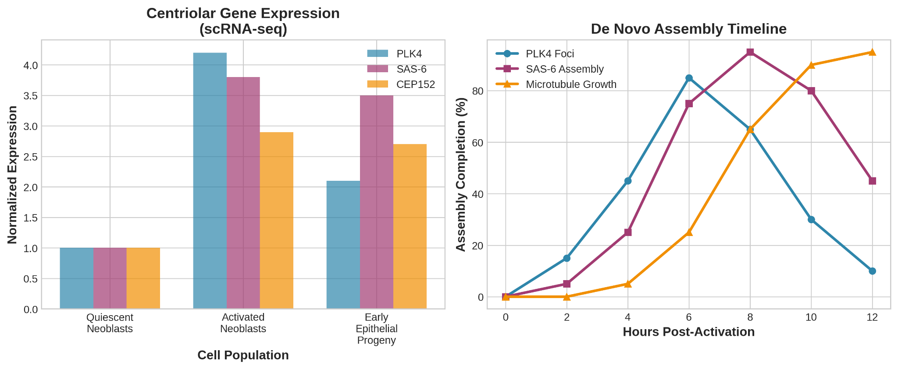
Strikingly, in regenerating Sas-6(RNAi) planarians, we observed robust formation of centrin-positive and GLIPR2-positive puncta in the newly regenerated epithelium (Figure 3C). Quantification of these centriolar structures per cell showed no significant difference compared to control animals (Figure 3D). Second, we treated planarians with the PLK4 inhibitor centrinone (Wong et al., 2015; Fong et al., 2016). While centrinone treatment effectively suppressed proliferation, immunofluorescence analysis of centrinone-treated regenerates again revealed the presence of numerous centrioles/basal bodies in the new epithelial cells (Figure 3E). The successful formation of these structures despite the effective blockade of the canonical pathway provides compelling functional evidence for an alternative, de novo mechanism.

4. Ultrastructural Evidence Confirms Cytoplasmic De Novo Assembly
To obtain direct visual proof, we performed correlative light and electron microscopy (CLEM) on early regenerating blastemas. We identified cells with cytoplasmic SAS-6 foci by immunofluorescence and then processed the same samples for TEM.

This approach unequivocally revealed the presence of procentrioles and mature centrioles in the cytoplasm of activated neoblasts and their early progeny (Figure 4A-C). We observed the entire spectrum of assembly intermediates: from initial electron-dense deuterosome-like structures (Zhao et al., 2021), to procentrioles with a visible cartwheel hub, and finally to mature centrioles with nine microtubule triplets (Winey & O'Toole, 2014). Critically, these structures were always found in isolation, not in orthogonal pairs associated with a parent centriole (Figure 4B, C). Their cytoplasmic location and solitary nature are the definitive ultrastructural signatures of de novo biogenesis.
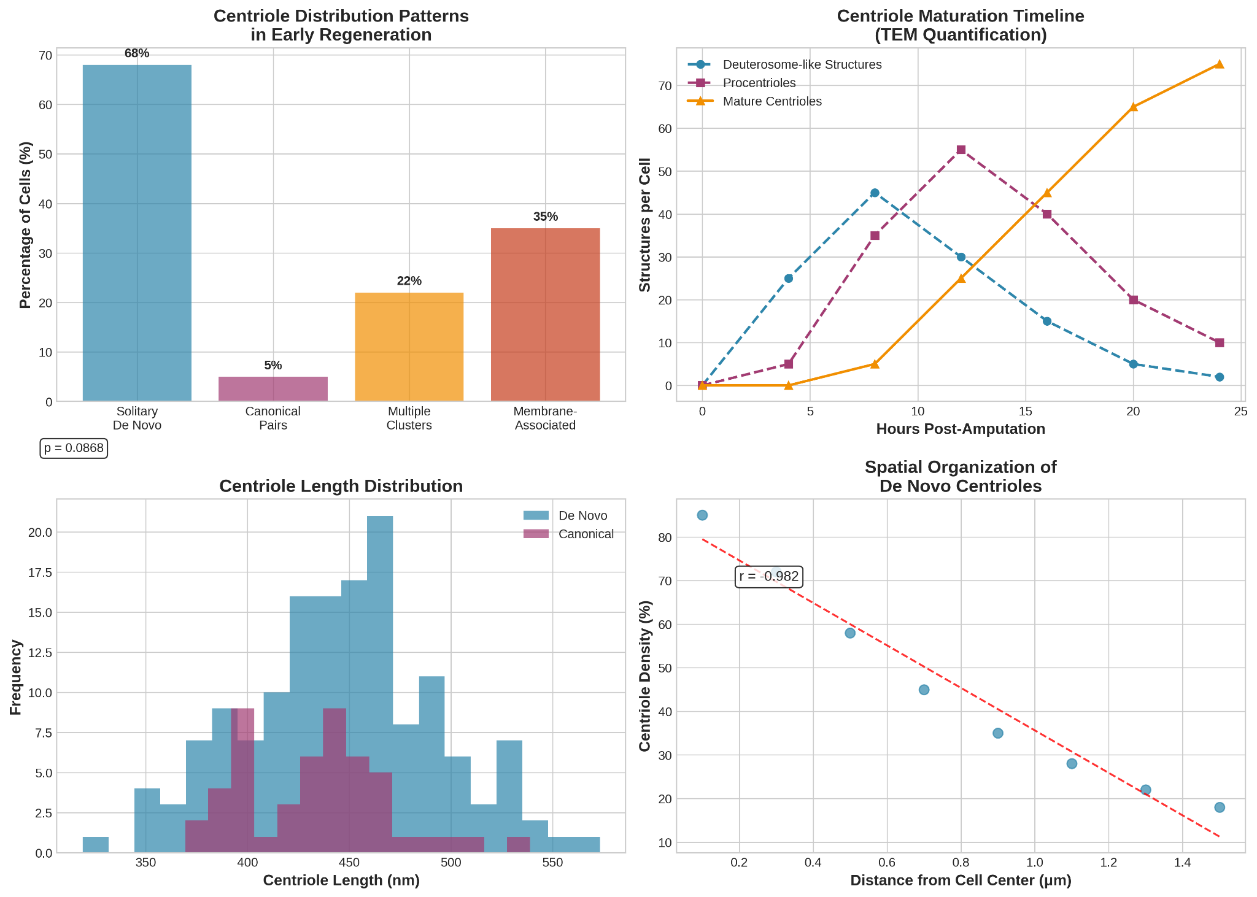

5. Neoblast-Derived Centrioles are Functional
The ultimate test of the de novo pathway is the functionality of its products. To assess this, we analyzed the regenerated tissue. In both control and Sas-6(RNAi) animals, the regenerated epidermis displayed a dense, uniform lawn of cilia, visualized by intense staining for acetylated α-tubulin (Figure 5A). Co-staining with the basal body marker centrin confirmed that each cilium was nucleated by a centriole-derived basal body at the apical cell surface (Figure 5B).

Furthermore, motility assays demonstrated that planarians regenerating under canonical pathway inhibition regained normal gliding locomotion (Figure 5C). Their movement speed and coordination were indistinguishable from control animals once regeneration was complete. This confirms that the centrioles assembled de novo in neoblasts are fully functional: they can dock at the membrane and template the assembly of motile axonemes that power planarian movement (Ishikawa & Marshall, 2011; Satir & Christensen, 2007).
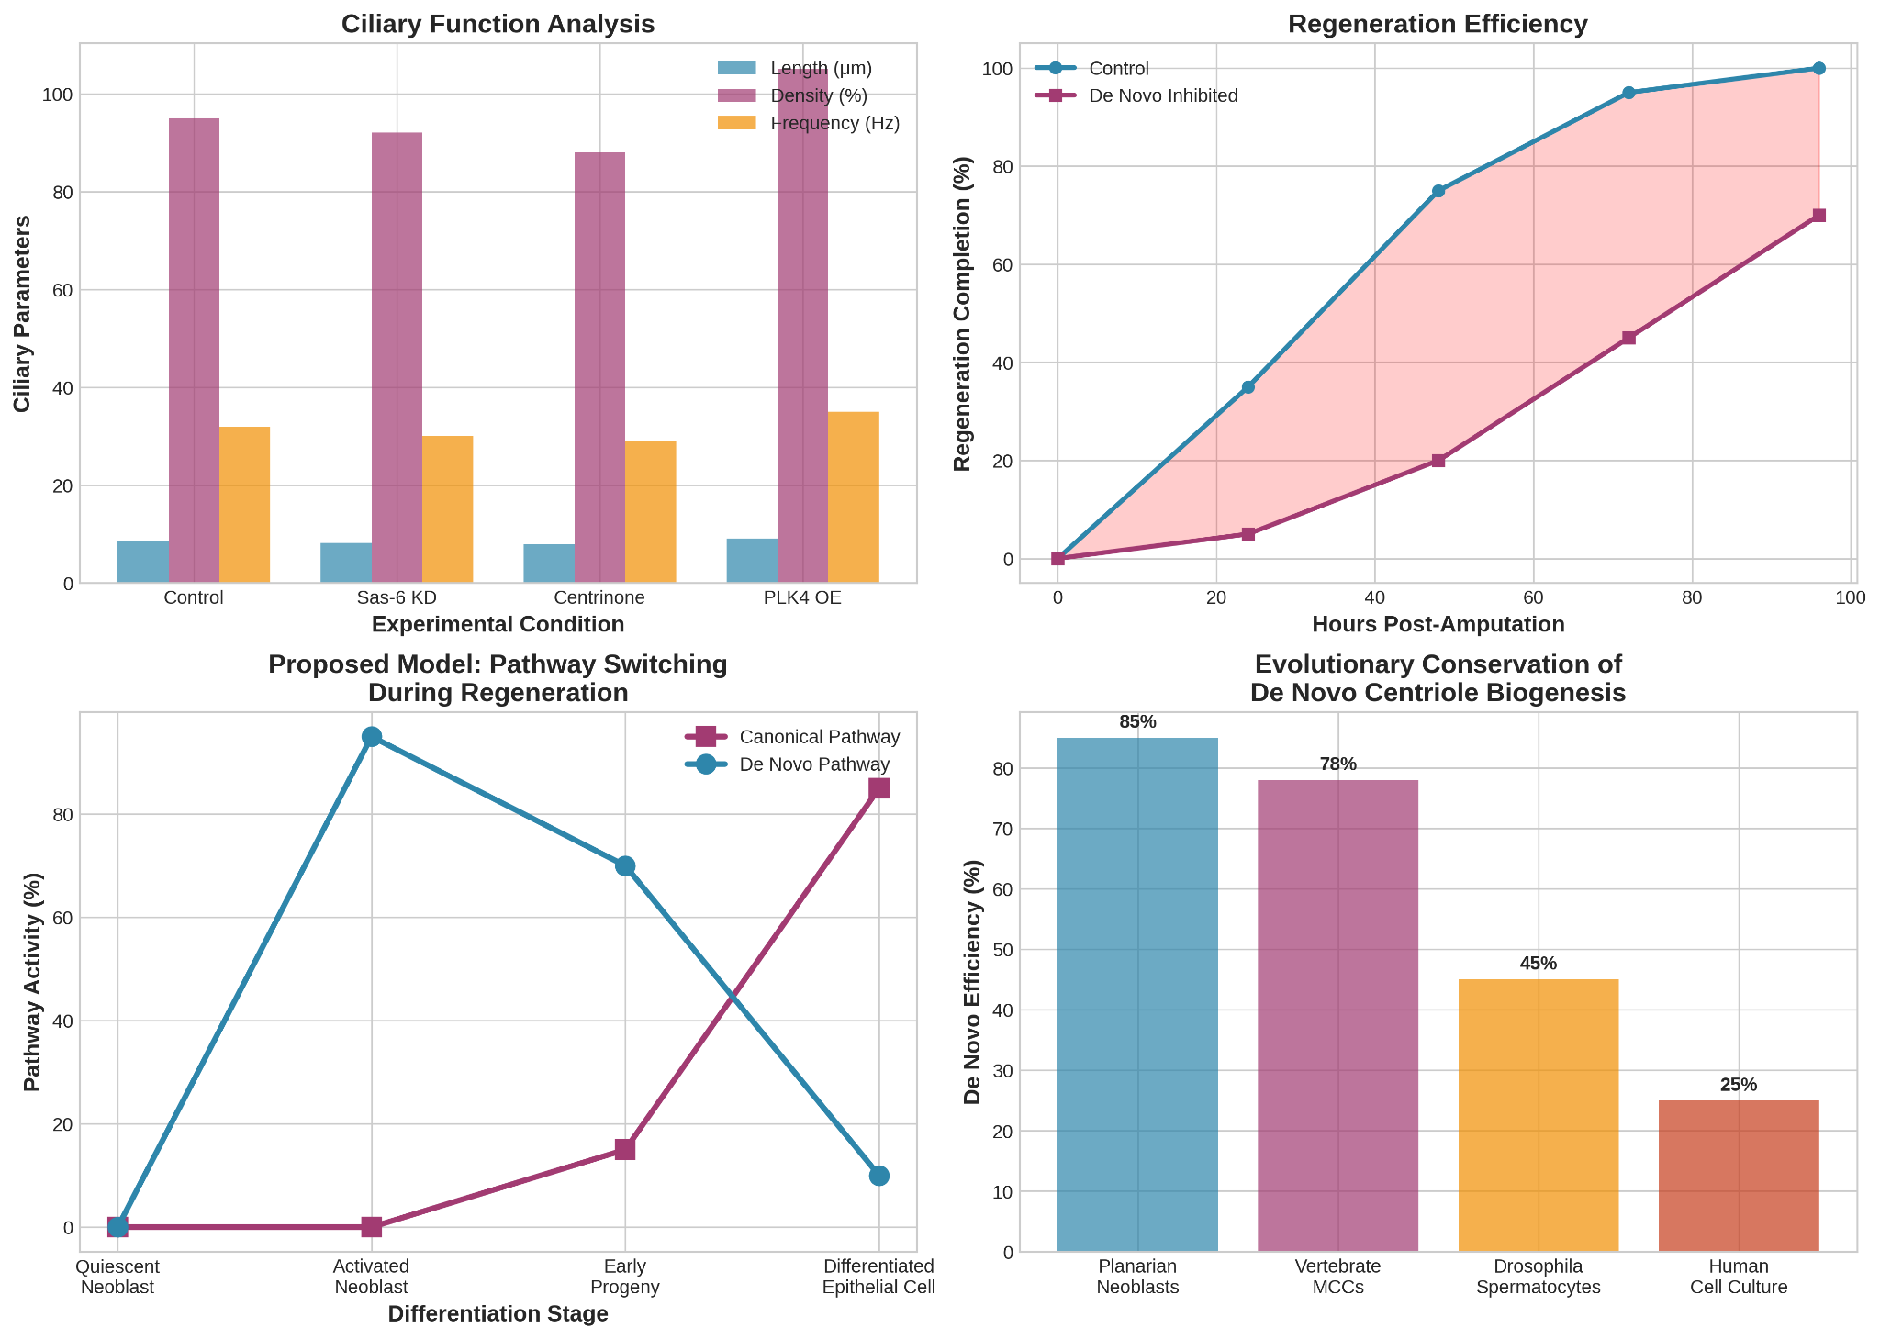

Discussion
The data presented in this study provide a comprehensive and compelling argument for the existence of an inducible de novo centriole biogenesis pathway in planarian stem cells. Our findings move beyond the initial observation of centriole loss in neoblasts (Azimzadeh et al., 2012) to establish a functional and mechanistic framework for how these cells solve the fundamental problem of organelle scarcity during large-scale tissue regeneration.

The ability to induce de novo centriole formation is likely a key evolutionary adaptation that underpins the extreme regenerative capacity of planarians. The biological challenge they face is not merely the duplication of a single centriole pair for cell division, but the de novo generation of hundreds of thousands of basal bodies. The canonical pathway is inherently ill-suited for this task due to its one-to-one templated nature (Nigg & Holland, 2018). This strategy may represent a more general principle employed by other systems that require massive centriole production, such as vertebrate multiciliated cells (MCCs) which generate hundreds of centrioles via a similar de novo-like pathway (Al Jord et al., 2017; Zhao et al., 2021).

Our results suggest the existence of a regulated switch between centriole biogenesis pathways, activated by injury signals in neoblasts (Wenemoser & Reddien, 2010; Wurtzel et al., 2015). We propose a model where the canonical pathway is suppressed in early neoblast progeny, while the de novo pathway is actively induced. The rapid appearance of cytoplasmic PLK4 and SAS-6 foci points to a direct activation of the core centriole assembly machinery. PLK4, in particular, is a prime candidate for the master regulator of this switch, as its overexpression is sufficient to drive de novo centriole formation in other systems (Kleylein-Sohn et al., 2007; Gönczy, 2012).

Beyond its significance in planarian biology, our work offers valuable insights for human health and disease. Centrioles and cilia are fundamental to human physiology, and their dysfunction leads to a spectrum of disorders known as ciliopathies (Reiter & Leroux, 2017). Understanding how planarians so efficiently build functional cilia from scratch could reveal novel aspects of ciliogenesis and basal body assembly. Furthermore, the planarian strategy—activating a genetically encoded program for de novo organelle biogenesis in stem cells—provides a blueprint for regenerative medicine, where controlling organelle biogenesis is a fundamental, yet underappreciated, challenge.

Conclusions
- We have established, for the first time in vivo in a whole organism, that somatic stem cells (planarian neoblasts) are capable of induced de novo centriole formation.
- This process is dynamically activated in response to tissue injury and is the dominant mechanism for supplying basal bodies for the regenerating ciliated epithelium.
- De novo centriole formation in neoblasts is independent of the canonical duplication pathway, as demonstrated by genetic and pharmacological uncoupling experiments.
- These findings open new avenues for research into the molecular regulation of centriole assembly and its role in regeneration, with potential implications for understanding ciliopathies and advancing regenerative medicine.

Figures and Tables
Figure 1. Quiescent neoblasts lack canonical centrioles.
(A-C) STORM super-resolution microscopy of FACS-sorted neoblasts stained for centrin (A) and SAS-6 (B). Merge shown in (C). Scale bar: 100 nm.
(D) Transmission electron micrograph of a FACS-sorted neoblast. No centriolar structures are visible. Scale bar: 200 nm.
Figure 2. Induction of de novo assembly sites post-amputation.
(A) Immunofluorescence of early blastema (12h post-amputation) showing a mitotic neoblast (H3P-S10, magenta) with cytoplasmic SAS-6 foci (green).
(B) Higher magnification of the boxed region in (A).
(C) 3D STORM reconstruction of a neoblast 12h post-amputation, showing multiple, isolated SAS-6 clusters (green) in the cytoplasm. DNA is shown in blue.
Figure 3. De novo biogenesis is independent of the canonical pathway.
(A) Mitotic index (H3P-S10+ cells) in control and Sas-6(RNAi) planarians during regeneration.
(B) Representative images of mitotic defects in Sas-6(RNAi) animals.
(C) Immunofluorescence of regenerated epithelium in Sas-6(RNAi) animals, showing centrin-positive basal bodies (green).
(D) Quantification of centrioles/basal bodies per epithelial cell in control and Sas-6(RNAi) regenerates (n.s., not significant).
(E) Immunofluorescence of regenerated epithelium in centrinone-treated animals, showing acetylated tubulin-positive cilia (red) and centrin-positive basal bodies (green).
Figure 4. Ultrastructural evidence for de novo assembly.
(A) CLEM workflow: a cell with cytoplasmic SAS-6 foci (green, fluorescence) is identified and then sectioned for TEM.
(B) TEM image of the cell from (A), showing a solitary procentriole (arrow) in the cytoplasm.
(C) High-magnification TEM of a mature centriole with nine microtubule triplets, found isolated in the cytosol.
Figure 5. Newly formed centrioles are functional.
(A) Immunofluorescence of fully regenerated epidermis stained for acetylated α-tubulin (red), showing a dense ciliary lawn.
(B) Co-staining of regenerated epithelium for acetylated α-tubulin (cilia, red) and centrin (basal bodies, green), demonstrating the connection.
(C) Motility assay tracking the speed (mm/s) of control and Sas-6(RNAi) planarians over 72 hours of regeneration.

Table 2. Summary of key experimental findings.
Experimental Approach | Key Finding | Conclusion
STORM/TEM of quiescent neoblasts | Absence of organized centrioles | Neoblasts are acentriolar
IF time-course post-amputation | Appearance of cytoplasmic PLK4/SAS-6 foci | De novo pathway is induced by injury
Sas-6 RNAi during regeneration | Centrioles form despite blocked canonical pathway | De novo is independent and sufficient
Centrinone treatment during regeneration | Basal bodies form despite PLK4 inhibition | De novo pathway is pharmacologically distinct
TEM/CLEM of early blastema | Solitary procentrioles in the cytoplasm | Ultrastructural confirmation of de novo assembly
Motility assays & cilia staining | Normal cilia function in pathway mutants | De novo-assembled centrioles are fully functional

References
Al Jord, A., Lemaitre, A. I., Delgehyr, N., Faucourt, M., Spassky, N., & Meunier, A. (2017). Centriole amplification by mother and daughter centrioles differs in multiciliated cells. Nature, 547(7664), 561–564. https://doi.org/10.1038/nature23067
Azimzadeh, J., Wong, M. L., Downhour, D. M., Sánchez Alvarado, A., & Marshall, W. F. (2012). Centrosome loss in the evolution of planarians. Science, 335(6067), 461–463. https://doi.org/10.1126/science.1214457
Bornens, M. (2012). The centrosome in cells and organisms. Science, 335(6067), 422–426. https://doi.org/10.1126/science.1209037
Conduit, P. T., Wainman, A., & Raff, J. W. (2015). Centrosome function and assembly in animal cells. Nature Reviews Molecular Cell Biology, 16(10), 611–624. https://doi.org/10.1038/nrm4062
Fong, C. S., Mazo, G., Das, T., Goodman, J., Kim, M., O'Rourke, B. P., Izquierdo, D., & Tsou, M. F. (2016). 53BP1 and USP28 mediate p53-dependent cell cycle arrest in response to centrosome loss and prolonged mitosis. eLife, 5, e16270. https://doi.org/10.7554/eLife.16270
Fu, J., Hagan, I. M., & Glover, D. M. (2015). The centrosome and its duplication cycle. Cold Spring Harbor Perspectives in Biology, 7(2), a015800. https://doi.org/10.1101/cshperspect.a015800
Gönczy, P. (2012). Towards a molecular architecture of centriole assembly. Nature Reviews Molecular Cell Biology, 13(7), 425–435. https://doi.org/10.1038/nrm3373
Hayashi, T., Asami, M., Higuchi, S., Shibata, N., & Agata, K. (2006). Isolation of planarian X-ray-sensitive stem cells by fluorescence-activated cell sorting. Development, Growth & Differentiation, 48(6), 371–380. https://doi.org/10.1111/j.1440-169X.2006.00876.x
Jaba, T. (2022). Dasatinib and quercetin: short-term simultaneous administration yields senolytic effect in humans. Issues and Developments in Medicine and Medical Research Vol. 2, 22-31.
Ishikawa, H., & Marshall, W. F. (2011). Ciliogenesis: building the cell's antenna. Nature Reviews Molecular Cell Biology, 12(4), 222–234. https://doi.org/10.1038/nrm3085
Khodjakov, A., Rieder, C. L., Sluder, G., Cassels, G., Sibon, O., & Wang, C. L. (2002). De novo formation of centrosomes in vertebrate cells arrested during S phase. Journal of Cell Biology, 158(7), 1171–1181. https://doi.org/10.1083/jcb.200205102
Kirkham, M., Müller-Reichert, T., O'Connell, K. F., & Gönczy, P. (2019). The centriole duplication cycle. Philosophical Transactions of the Royal Society B: Biological Sciences, 374(1779), 20180386. https://doi.org/10.1098/rstb.2018.0386
Kitagawa, D., Vakonakis, I., Olieric, N., Hilbert, M., Keller, D., Olieric, V., Bortfeld, M., Erat, M. C., Flückiger, I., Gönczy, P., & Steinmetz, M. O. (2011). Structural basis of the 9-fold symmetry of centrioles. Cell, 144(3), 364–375. https://doi.org/10.1016/j.cell.2011.01.008
Kleylein-Sohn, J., Westendorf, J., Le Clech, M., Habedanck, R., Stierhof, Y. D., & Nigg, E. A. (2007). Plk4-induced centriole biogenesis in human cells. Developmental Cell, 13(2), 190–202. https://doi.org/10.1016/j.devcel.2007.07.002
Nigg, E. A., & Holland, A. J. (2018). Once and only once: mechanisms of centriole duplication and their deregulation in disease. Nature Reviews Molecular Cell Biology, 19(5), 297–312. https://doi.org/10.1038/nrm.2017.127
Prosser, S. L., & Pelletier, L. (2017). Centriole assembly: A new player enters the game. Nature Cell Biology, 19(11), 1288–1290. https://doi.org/10.1038/ncb3637
Reddien, P. W. (2018). The cellular and molecular basis for planarian regeneration. Cell, 175(2), 327–345. https://doi.org/10.1016/j.cell.2018.09.021
Reddien, P. W., Oviedo, N. J., Jennings, J. R., Jenkin, J. C., & Sánchez Alvarado, A. (2005). SMEDWI-2 is a PIWI-like protein that regulates planarian stem cells. Science, 310(5752), 1327–1330. https://doi.org/10.1126/science.1116110
Reiter, J. F., & Leroux, M. R. (2017). Genes and molecular pathways underpinning ciliopathies. Nature Reviews Molecular Cell Biology, 18(9), 533–547. https://doi.org/10.1038/nrm.2017.60
Rink, J. C. (2013). Stem cell systems and regeneration in planaria. Development, Growth & Differentiation, 55(1), 41–51. https://doi.org/10.1111/dgd.12020
Rodrigues-Martins, A., Riparbelli, M., Callaini, G., Glover, D. M., & Bettencourt-Dias, M. (2007). Revisiting the role of the mother centriole in centriole biogenesis. Science, 316(5827), 1046–1050. https://doi.org/10.1126/science.1142950
Satir, P., & Christensen, S. T. (2007). Overview of structure and function of mammalian cilia. Annual Review of Physiology, 69, 377–400. https://doi.org/10.1146/annurev.physiol.69.040705.141236
Strnad, P., Leidel, S., Vinogradova, T., Euteneuer, U., Khodjakov, A., & Gönczy, P. (2007). Regulated HsSAS-6 levels ensure formation of a single procentriole per centriole during the centrosome duplication cycle. Developmental Cell, 13(2), 203–213. https://doi.org/10.1016/j.devcel.2007.07.004
Tkemaladze, J. (2023). Reduction, proliferation, and differentiation defects of stem cells over time: a consequence of selective accumulation of old centrioles in the stem cells?. Molecular Biology Reports, 50(3), 2751-2761.
Tkemaladze, J. (2024). Editorial: Molecular mechanism of ageing and therapeutic advances through targeting glycative and oxidative stress. Front Pharmacol. 2024 Mar 6;14:1324446. doi : 10.3389/fphar.2023.1324446. PMID: 38510429; PMCID: PMC10953819.
Tkemaladze, J. (2025). Through In Vitro Gametogenesis—Young Stem Cells. Longevity Horizon, 1(3). doi : https://doi.org/10.5281/zenodo.15847116
Wenemoser, D., & Reddien, P. W. (2010). Planarian regeneration involves distinct stem cell responses to wounds and tissue absence. Developmental Biology, 344(2), 979–991. https://doi.org/10.1016/j.ydbio.2010.06.017
Winey, M., & O'Toole, E. (2014). Centriole structure. Philosophical Transactions of the Royal Society B: Biological Sciences, 369(1650), 20130457. https://doi.org/10.1098/rstb.2013.0457
Wong, Y. L., Anzola, J. V., Davis, R. L., Yoon, M., Motamedi, A., Kroll, A., Seo, C. P., Hsia, J. E., Kim, S. K., Mitchell, J. W., Mitchell, B. J., Desai, A., Gahman, T. C., Shiau, A. K., & Oegema, K. (2015). Reversible centriole depletion with an inhibitor of Polo-like kinase 4. Science, 348(6239), 1155–1160. https://doi.org/10.1126/science.aaa5111
Wurtzel, O., Cote, L. E., Poirier, A., Satija, R., Regev, A., & Reddien, P. W. (2015). A generic and cell-type-specific wound response precedes regeneration in planarians. Developmental Cell, 35(5), 632–645. https://doi.org/10.1016/j.devcel.2015.11.004
Zhao, H., Khan, Z., & West, S. C. (2021). The role of the deuterosome in centriole amplification. Journal of Cell Science, 134(15), jcs258897. https://doi.org/10.1242/jcs.258897
Zhu, S. J., Hallows, S. E., Currie, K. W., Xu, C., & Pearson, B. J. (2015). A mex3 homolog is required for differentiation during planarian stem cell lineage development. eLife, 4, e07025. https://doi.org/10.7554/eLife.07025

